Assembly 2570 Fourth Degree Newsletter
August 2021
The August monthly meeting was held at Vetoni’s in Gun Barrel City on the 22nd. Attendance was good in spite of the lingering concerns regarding the latest COVID virus outbreak. The faithful navigator presented highlights from the Knights of Columbus Supreme National Convention where he served as a delegate for the Texas State Council. Theme for the convention was “Called to Creative Courage”. The formal announcement was also made of the Texas State Council reaching the Circle of Honor.
The faithful navigator also briefed on attending all local council meetings during the past several months and encouraging eligible knights to consider joining the Fourth Degree. He also reminded all sir knights that each is called to the aforementioned “Creative Courage” which includes bringing men back to our churches and asking them to become a knight and specifically a fourth degree knight.
The faithful navigator also reported on recent communications with the staff at the Dallas VA Hospital and has a list of needed items. He will purchase the items and has arranged to drop off the items in the afternoon of October 10th as they still are not allowing face to face visits. A letter of appreciation from the hospital regarding past donations has also been received.
Special Announcement! The Assembly website is up and running thanks to SK Christopher Mix. Great job Chris and thanks for all the hard work.
The Color Corps commander Juan Martinez, but the assembly cannot provide a color corps for any event as there are not enough sir knights having the new uniform!
SK Joe Lomonaco presented the draft of the revised Member Memorial Protocol and Committee procedures. Discussion followed! The draft procedures and Last Requests Form will be promulgated to members for comment.
Special recognition was given to our local councils as it was announced that council 10524 achieved Star Award status, council 11978 achieved Star Award status, council 12253 achieved Star Award status and council 8806 was awarded the Columbian Award. Well Done!
Next scheduled major events include:
Sept. 10, Dallas VA Hospital delivery.
Sept. 11, Exemplification in McKinney (No candidates from Assembly 2570.)
Sept. 26, Monthly meeting, 5 PM at Vetoni’s. (Pending health concerns/guidance.)
Oct. 3, Chain of Life at Athens Square 2- 3:30 PM (possible social after).
Oct. 11, Sanctity of Life Banquet in Tyler.
Oct. 24, Monthly meeting, 5 PM at Vetoni’s
Nov. 20, Corporate Mass, Memorial Ceremony; followed by a dinner social.
Dec. 18, Wreaths Across America followed by lunch at the Athens parish hall.
The assembly was once again featured in the Knight Line on the State Council website for the Flag Retirement Ceremony.
Pictured below is a photo from the Flag Retirement Ceremony on June 14th. Left to right: Representative Keith Bell, Fr. Lowry, FN Larry Pfeifer with Joe Lomonaco, Christopher Mix, and Thomas Calderon in the background.
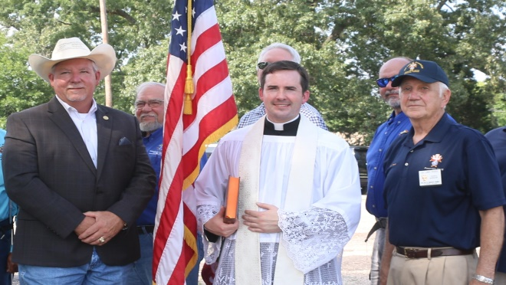
Pictured below are sir knights Christopher Mix, Gabriel Martinez, Wray Morris, and Thomas Calderon adding flags to the retirement fire.
