Assembly 2570 Fourth Degree Newsletter
December 2021
MERRY CHRISTMAS
The Assembly sir knights have remained active through the last few weeks of the year while contending with the lingering COVID issues. Sir Knights led many activities in their respective councils with GK John Sumpter and GK Juan Matinez promoting youth activities through the Keep Christ in Christmas Poster Program. Both Council 10524 and Council 12253 had participants proceeding to the diocese and state level competitions. State level winners will be announced after the first of the year
The Assembly is continuing the efforts to award as many ACE Wings as possible during this fraternal year in the Tyler Diocese. The requirements for the award of the wings will be sent to all members again under separate cover. The wings are a clear and visible declaration of our support of the unborn. It is time for all of us to stand and to be counted as supporting the sanctity of life.
Reminder, the Assembly has a website. Please visit the website to keep track of scheduled events and catch up on news and past events. Sir Knights are also encouraged to contribute articles and photos to help document the accomplishments of our assembly.
Send articles to Chris Mix. The local councils are encouraged to have a link on their council web site to the assembly web site.
Silver Rose services and prolife rose presentation ceremonies were conducted at our local parishes during the past few weeks. Thank you to Fr. Bowlin, Fr. Lowry, Fr. Jesudoss and Fr. Fenton for promoting and leading those Knights of Columbus sponsored services.
On Dec. 18, Assembly sir knights and ladies participated in the Wreaths Across America ceremonies starting at 11:00 at the Athens Cemetery. Simultaneously, SK John Sumpter coordinated the services at the MQH Cemetery and Sir Knight Joe Lomonaco participated in ceremonies at the Mabank Cemetery. After those opening ceremonies, the knights assisted in placing over eight hundred wreaths on the graves of veterans buried in six local cemeteries.
A special thank you to all who assisted in this program; John and Maxine Sumpter, Chris Mix, Mel & Maria Hebert, Wray and Carletta Morris, Jerry and Judy Nolan, Albert Vilallva, Juan and Hope Martinez, Tom Calderon, and Larry and Karen Pfeifer. After the services, Fr. Lowry and the knights and ladies met at the St Edward parish for a social over hot chili and chili dogs.
Next scheduled major event:
January 22nd. Mass of Reparation at the Cathedral in Tyler at 12:00. This has been selected as a major prolife activity for the assembly. Participation in this Mass will count for ACE Wing Award credit. This will be a “Fall out” for those with the new uniform. We have tentatively scheduled to meet for a late lunch after the Mass.
Pictured below is Fr. Lowry, seminarian Christopher and SK’s Calderon, Pfeifer, Mix, Hebert, and Morris.
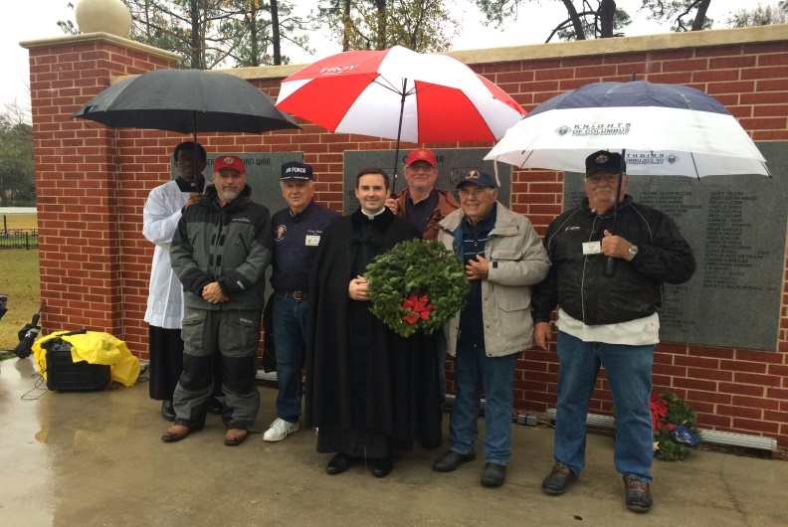
Pictured below is Sir Knight Wray Morris placing a wreath on a veteran’s grave at the Athens Cemetery.
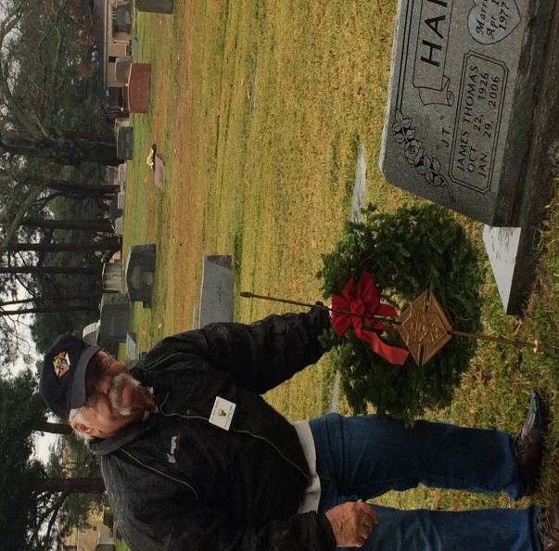
The following page contains a news article regarding the assembly memorial services submitted to the Texas Knight.

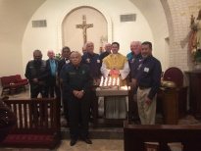
November 20, 2021 Athens, Texas By: Larry Pfeifer
Remembering Departed Sir Knights
On November 20, Sir Knights and ladies of Assembly 2570 gathered for a memorial honoring all departed sir knights of the assembly. The memorial started with Mass at St. Edward church officiated by Pastor Fr. Nolan Lowry which was followed by a ceremony honoring each of the deceased members of the Assembly. As their names were read aloud the bell was rung. The widows of the departed sir knights in attendance were escorted to the altar where they lighted a candle in memory of their departed sir knights.
After the formal memorial Mass and ceremony the sir knights, ladies, widows, and Fr. Lowry enjoyed a great meal together. Sir Knights are never forgotten.
Pictured below is Fr. Lowry with Assembly 2570 officers and sir knights at the conclusion of the assembly Memorial Mass and ceremony for departed knights.
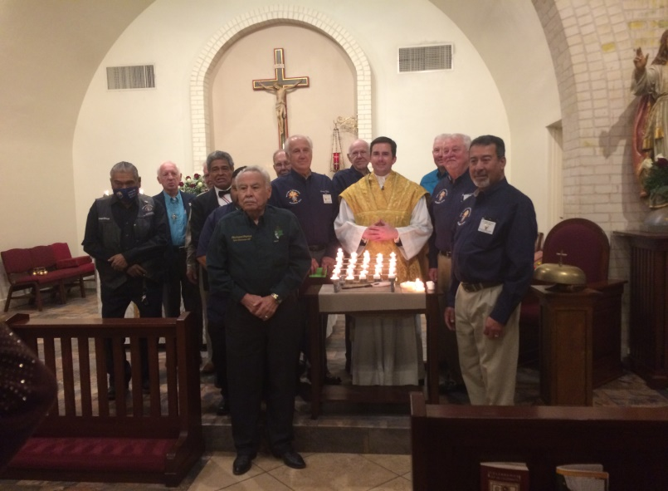

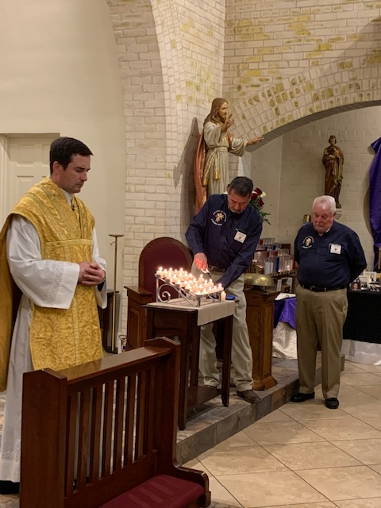

Pictured above is Fr. Lowry offering prayers as Sir Knights Albert Vilallva and John Sumpter light candles in remembrance of departed sir knights.

