Assembly 2570 Fourth Degree

Newsletter June 2021

The June monthly meeting was held at St. Edward parish hall. Highlight s from the meeting included a report regarding the assembly’s recent contributions of personal items for patients at the Dallas VA Hospital. The items were delivered by Faithful Navigator Larry Pfeifer. The Faithful Navigator also reported on the Flag Retirement ceremony held on June 14th. Sir Knights participating in the ceremony included: Freddy Hancock, Wray Morris, Mel Hebert, Christopher Mix, Jerald Nolan, Oscar Salazar, Joe Lomonaco and Gabriel Martinez. The Athens Review ran a front page article reporting the event and a photo feathering Representative Keith Bell who was the keynote speaker and Fr. Lowry who lead the invocation. After the regular business meeting the officers for the 2021-2022 fraternal year were installed virtually by District Master Ken Franch. The officers installed were:

Faithful Navigator Larry Pfeifer

Faithful Comptroller John Sumpter

Faithful Scribe Robert Garrett

Faithful Admiral Ray Snyder

Faithful Captain Jerald Nolan

Faithful Pilot Albert Villalva

Faithful Purser Richard Avery

Faithful Sentinel Oscar Salazar

Faithful Sentinel Joe Castello

Faithful Trustees Wray Morris, Mel Hebert, and Joe Lomonaco

Color corps commander Juan Martinez

Note: The assembly is still working to form an official color corps which requires a minimum of four sir knights in the new uniform. We can do that!

After the installation of the new officers the sir knights and ladies gathered at Tilo’s restaurant for and enjoyable meal and a time for socializing. Pictured below:

Pictured below is a photo from the Flag Retirement Ceremony on June 14th. Left to right: Representative Keith Bell, Fr. Lowry, Larry Pfeifer with Joe Lomonaco, Christopher Mix, and Thomas Calderon in the background.

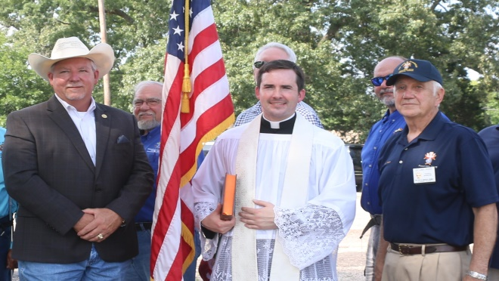

Pictured below are sir knights Christopher Mix, Gabriel Martinez, Wray Morris, and Thomas Calderon adding flags to the retirement fire.

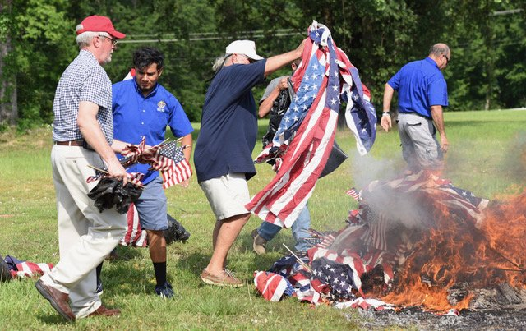

Pictured below is a copy of the Athens review article regarding the Flag retirement ceremony.

