Assembly 2570 Fourth Degree Newsletter
March 2022 Lent is here

We had a very good meeting on the 27th at the St. Edward Education Ministry (SEEM) facility. This will be the location for our assembly meetings moving forward. The meal was catered by Tilo’s and by all reports it was enjoyed by all. Thanks to the ladies for helping arrange tables and preparing for the social. The winner of the 50-50 did not want to have her name mentioned; I think she was concerned the sir knights might ask for a loan. All good. Most of the sir knights have been staying busy this month helping with the fish fry events sponsored by the local councils. The latest word I received is that Council 11978 (Canton) will be having their regular fish fry this Friday. I can attest that the fish was very good and the sides were also great when I participated in one of their events a few weeks ago. Also saw sir knights Oscar and Jerry with ladies enjoying some of the good food in Canton. The Athens Council 10524 has their fish fry scheduled for April 8th. Sir Knights Wray, Mel, Freddy, Bob, and Juan will be busy in the kitchen that afternoon. I also had the opportunity to enjoy some fish and shrimp at the Council 8806, Gun Barrel City, fish fry a couple of weeks ago. I know Sir Knights Jerry, Oscar, and Joe will be busy this weekend as the council again has a fish fry on Friday and will also be serving breakfast on Sunday after the 9 AM Mass. These are great opportunities for all to the support our sir knights and our local councils as they raise money for charity.
The big event for the Tyler Diocese was the Right To Life East Texas banquet on March 26th in Longview. The Knights of Columbus of the Tyler Diocese were honored at the banquet as the Pro-Life Organization of the Year. Bishop Strickland attended the event along with many sir knights and ladies from our assembly. This event and our sir knights were featured on the front page of the Texas Council web site. Several pictures are attached below.
The promotion of the ACE Wing program will continue to be a part of monthly newsletters as we are facing a critical time in our nation and we want to be counted as those who stand for the sanctity of life. The assembly is continuing the effort to award as many ACE Wings as possible during this fraternal year.

The next exemplification for the Fourth Degree is scheduled for June 4th in Longview. All the details regarding this event were presented at the meeting, but another email with details attached will be sent to all sir knights. All members attending must register for the event and pay for their meal as well as the meal for their spouse. The registration forms and payments will be collected at the April meeting. Make checks payable to the assembly and we will send one check for all attending. Forms 4 are available at your councils for any member you wish to propose for membership in the Fourth Degree and our assembly. All paperwork must be completed at the next meeting so it can be submitted to meet the deadline.
There is a possibility of having the installation of officers on the same day and location as the exemplification. Details are still being discussed and planned.
Fourth Degree District 3 meeting was held on March 5th in Ft. Worth. Comptroller John Sumpter was our delegate as the faithful navigator was attending a state council event in San Antonio. By all reports, John did a great job in presenting the activities and accomplishments of our assembly during the past two fraternal years.
Next scheduled events:
April 24, monthly meeting at 5 PM in the St. Edward SEEM. Candidates for admission to the assembly will be presented and discussed. Dinner following the meeting which is currently planned to be bar-b-que catered by Danny’s. Trustees to present slate of officers for next fraternal year.
May 22, monthly meeting at 5 PM in the St. Edward SEEM. Monthly meeting followed by a catered dinner. First order of business will be the election of officers for the next fraternal year. The draft of the Assembly Patriotic Program for the next fraternal year as well as the draft budget will also be presented.
June 4, Exemplification in Longview. The installation of the newly elected officers is tentatively planned to be conducted in conjunction with the exemplification.
June 14, Flag Retirement Ceremony to be held in the park adjacent to TVCC. Tentatively scheduled to start at 5 PM with a dinner and social at a local restaurant to follow.

Pictured below are FN Larry Pfeifer, Bishop Strickland, and State Deputy Alfredo Vela after the presentation of the Outstanding Pro-Life Organization of the Year to the Tyler Knights of Columbus.
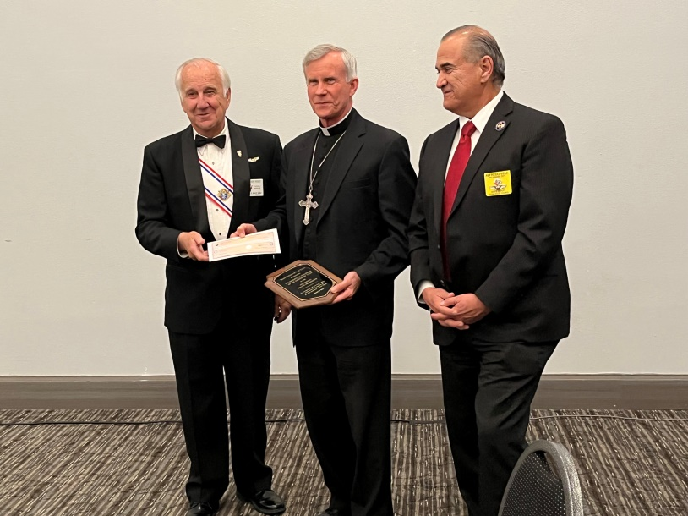
Pictured below are Faithful Navigator Larry Pfeifer accepting the Pro-Life Organization of the Year on behalf of the Tyler Diocese Knights of Columbus from Susan Wells, president of the Right To Life East Texas organization.
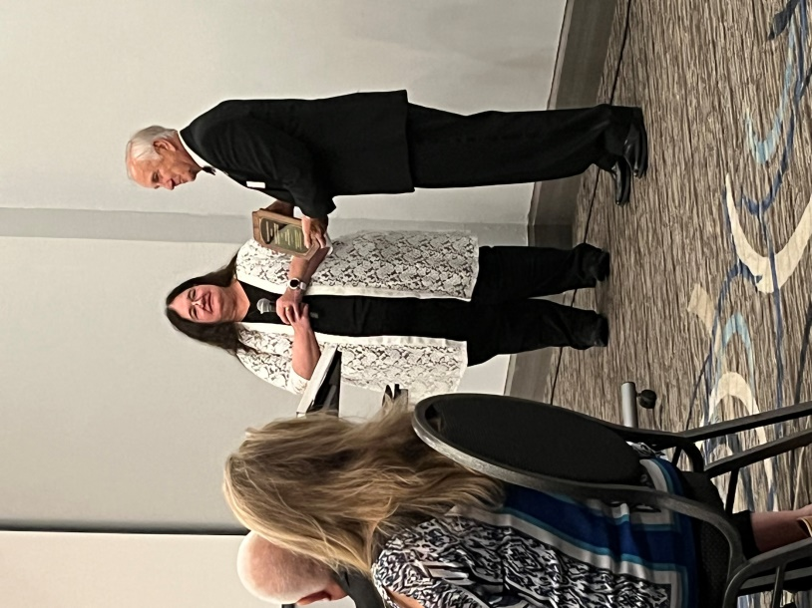

Pictured below are some of the many Knights of Columbus who attended the Right To Life East Texas banquet including John Sumpter, Juan Martinez and Larry Pfeifer.
