Assembly 2570 Fourth Degree Newsletter May 2022
Memorial Day
We honor the memory of all those who have served our great nation.
We are truly blessed to live in this great nation. This past weekend as we gathered with family and friends to celebrate, we also paid tribute and remembered the service of the many deceased men and women who have worn the uniform of our military armed forces in protection of our many freedoms. As members of the patriotic degree of the Knights of Columbus this day is of importance to us and many of us, along with family members, participated in memorial ceremonies or visited cemeteries this past weekend. It was a time of enjoying family and friends and to honor the service of deceased veterans, but it was also a time for reflection and prayers for all those who are enduring the hardships that have befallen one of our communities as the result of senseless violence. I am sure all of us included the families in Uvalde in our prayers as they attempt to recover from the tragic loss of life in their community. Prayers are always needed but for those who want to do more, there is a link at the end of this newsletter for making financial contributions through the Knights of Columbus to support the relief efforts for the Uvalde community victims.
Our last meeting was held on May 22nd at the St. Edward Historic Campus Parish Hall followed by a great meal catered by 6 Forks. The main action item during the meeting was the election of officers for the next fraternal year. Congratulations to SK Jerry Nolen as he will be serving as the faithful navigator the next fraternal year and congratulations to the entire slate of officers elected to their new positions. A list of all newly elected officers is attached.
Promotion of the ACE Wing program has been an on—going focus of the assembly during this past fraternal year. We plan to award wings to two sir knights and ladies at the next meeting on June 26th at the St. Edward Historic Campus parish hall. If you have completed all the requirements to be awarded the ACE Wings, please get the form to me quickly so we can get it processed. It would be great if had a large number of sir knights and ladies getting their wings during the aforementioned ceremony. We are facing a critical time in our nation and we want to be counted as those who stand for the sanctity of life.

Bishop Strickland celebrated Mass and confirmation on May 25th at St. Edward SEEM. The bishop appreciated the presence of the Knights of Columbus at the service and he expressed his appreciation of the honor guard provided by the knights during his homily. The St. Edward parish now has enough sir knights with the new uniform to be able to provide for a color corps/honor guard for parish functions. Well done sir knights. Pictured below: SK James Kennerly, SK Juan Martinez, FN SK Larry Pfeifer, and DD SK Tom White.

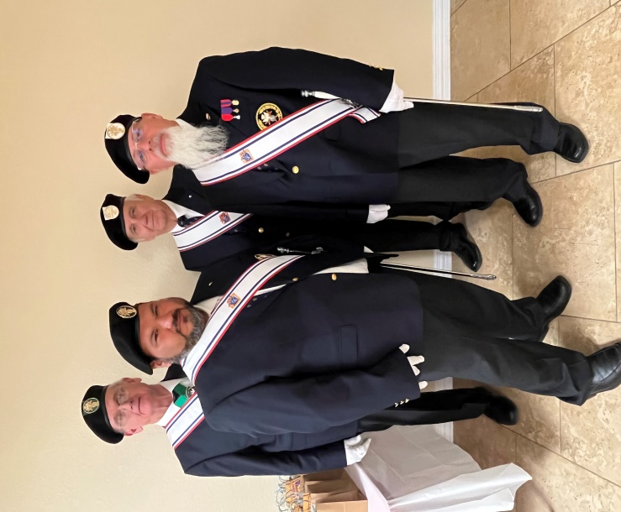
Next scheduled events:
June 4, Exemplification in Longview. The next exemplification for the Fourth Degree is scheduled for June 4th in Longview. The assembly has not recruited any brother knights to join our assembly.
June 14, Flag Retirement Ceremony to be held in the park adjacent to TVCC. Scheduled to start at 5 PM with a dinner and social at a local restaurant to follow.June 26, Regular meeting and celebration at the St. Edward Historic Campus Parish Hall. Meeting at 5 PM followed by dinner, celebrations, and ACE Wing presentations.
You can make a donation online at tkofc.org. The state office phone number is (512) 442-1492

PP
Photos of Memorial Day services at the St. Fidelis Catholic Cemetery in Victoria Kansas. Knights of Columbus veterans served as members of the firing squad for services at four cemeteries during weekend ceremonies.

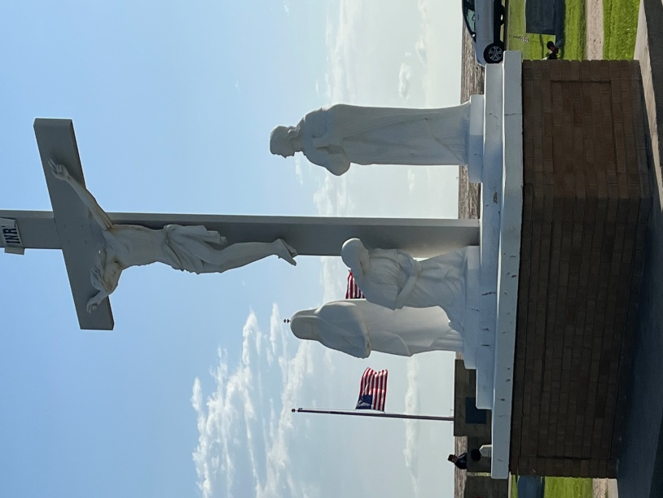

Pictured below are four of the five Pfeifer family veterans who were members of the firing squad. Left to right is David Pfeifer and Timothy Pfeifer, nephews of FN Larry Pfeifer pictured on the far right. Dale Pfeifer, brother of FN Larry Pfeifer is standing next to Larry.
Not pictured is Al Pfeifer, also a brother of FN Larry, who was the fifth member of the Pfeifer knight-veteran team for services that weekend.
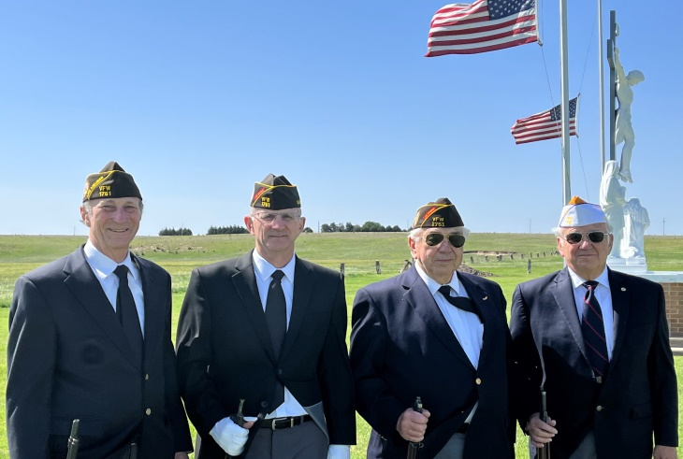

KNIGHTS OF COLUMBUS-FOURTH DEGREE ASSEMBLY
2570 OUR LADY OF GUADALUPE
OFFICERS / Candidates, FY 2022 – 2023

Faithful Friar- SK Father Nolan Lowry

Faithful Navigator- SK Jerald L Nolan

Faithful Captain - SK Juan G Martinez

Faithful Comptroller - SK John J Sumpter

Faithful Admiral - SK Lawrence E Pfeifer

Faithful Purser- SK Richard Avery

Faithful Pilot- SK Oscar G Salazar

Faithful Scribe- SK Edward Anaya

Faithful Inner Sentinel- SK Joe F Castillo

Faithful Outer Sentinel- SK Dennis Livingston

Faithful First Year Trustee- SK Wray Morris

Faithful Second Year Trustee- SK Joseph J Lomonaco lll

Faithful Third Year Trustee- SK Mel C Hebert

Faithful Color Corp Commander- SK Juan Martinez

