Assembly 2570 Fourth Degree Newsletter November 2020

COVID restrictions and concerns continue. The November monthly meeting was via zoom. Attendance was limited to a few of technically savvy members or simply those with good or better internet service. Highlights from the meeting included the announcement of new sir knights joining Assembly 2570. Those completing the exemplification in June were Gabriel Martinez from Council 10524 in Athens and joining from Council 11978 in Canton is Ramiro Gonzalez and Dennis Livingston. We had several sir knights completing their exemplification in September including from the Canton council Carlo Caravetta and from the Athens council Robert Fletcher. The last group of sir knights joining the assembly completed their exemplification October and they are Thomas Calderon from the Athens council and John Schmitz from the Malakoff council. Welcome to all new sir knights and we hope to see you and your ladies at many assembly meetings and activities.

Memorial Mass and ceremony was held at the St Edward Historic Church campus on November at 5 PM with Fr. Lowry officiating. The memorial ceremony was completed in the parish church and honored all the departed sir knights. This has been a difficult year for the assembly as we lost four brothers: Davey Arroyo, Jerry Gandy, Samuel Miramontes and Davey Arroyo.

Following the ceremony an Italian pasta meal was enjoyed by all including some special fruit of the vine beverages. Special thanks to Wray Morris for preparing the great food and Anne Mix, Carletta Morris, Freddy Hancock, and Karen Pfeifer for helping to prepare the hall and serving the meal.

Pictured below are several new sir knights at their exemplification earlier in the year. New sir knights left to right in the front row: Gabriel Martinez from Council 10524, Dennis Livingston from Council 11978, and Ramiro Gonzalez from Council 11978. 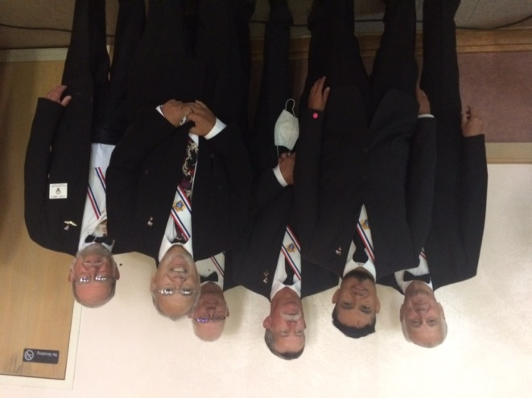

Pictured below from left to right are new Sir Knights Carlo Caravetta from Council 11978, Faithful Navigator Larry Pfeifer in the center and Robert Fletcher from Council 10524

