Assembly 2570 Fourth Degree
Newsletter October 2020
The October monthly meeting was held via zoom due to the on-going COVID restrictions on the 25th.
The biggest news at this meeting was the announcement that we have two new sir knights in our assembly. Tom Calderon from Council 10524 and John Schmitz from council 12253 recently completed their exemplifications at Farmers Branch. Congratulations and welcome to the team.
FN reported the shirt order is still in progress, but the art work needs some changes and corrections before it can be accepted. FN will send the order form out again.
The Chain of Life at the Athens Square on October 4th from 2-4 PM was well attended. Thanks to SK Juan Martinez for being the team leader for this event.
The next event on the schedule is the Memorial Mass and ceremony honoring our departed sir knights. The Mass is scheduled for 5 P M on November 29th with the ceremony following immediately after the Mass. There will be a diner/social after the ceremony and all activities are scheduled for the St. Edward Historic Campus.
Our sir knights are also very active with council activities as the councils work to complete their commitments to charity activities and help our communities. Part of those activities included providing wheelchairs to members of the community. Below is a copy of an article covering those activities that appeared in the Texas Knight.
Making Mobility Happen….One Wheelchair at a Time
Assembly 2570 sir knights took on a project to bring mobility to several senior citizens in Henderson and Van Zandt counties. Through the effort of Former Diocesan Deputy David Zeigler, the Tyler Diocese was able to obtain a small container of wheelchairs for the diocese. All councils that had contributed to the Wheelchair Mission for a two year period were then allocated several wheelchairs for their respective councils. At that point in the process, sir knights of Assembly 2570 stepped in to get those available chairs delivered to the councils in District 131 and then to the most needy in their communities.

SK Ramiro Gonzales distributed chairs to the St Therese parish, a senior citizen in the Canton community, and also to a community outreach facility. SK Juan Martinez coordinated the efforts for the Athens community starting with a chair for the new St. Edward Education Ministry facility. He then reached out to senior members of the Hispanic community for those needing a wheelchair. One recipient, Celedina Martinez was delighted to receive a chair as it gave her new freedom through mobility. SK Wray Morris reached out to the local VFW post and made a chair available for any veteran or family member in need of a wheelchair.
SK’s John Schmitz and John Sumpter were very active delivering wheelchairs to those in need of one in the Malakoff area, starting with Ms. Pat Kamp. The Fox news outlet in Tyler had heard of the Knights of Columbus wheelchair program and sent a reporter to Malakoff to interview Pat and members of her family after she received her wheelchair. MS Kamp expressed great appreciation for the gift of the wheelchair as it gave her independence once again through mobility. Her daughters also expressed appreciation and explained how the wheelchair had also affected their lives as they too had gained greater independence through their mother’s newly acquired mobility. There was not a dry eye in the hall as they related the changes in their lives because of one wheelchair.
The Sir Knights again teamed up to present another wheelchair to a Mary Queen of Heaven parish member lacking mobility. The picture below shows Fr. Fenton with SK John Schmitz, MS Cabrera and members of her family. John Schmitz also provided a wheelchair for a veteran in an assisted living facility where he was recovering from a broken hip.

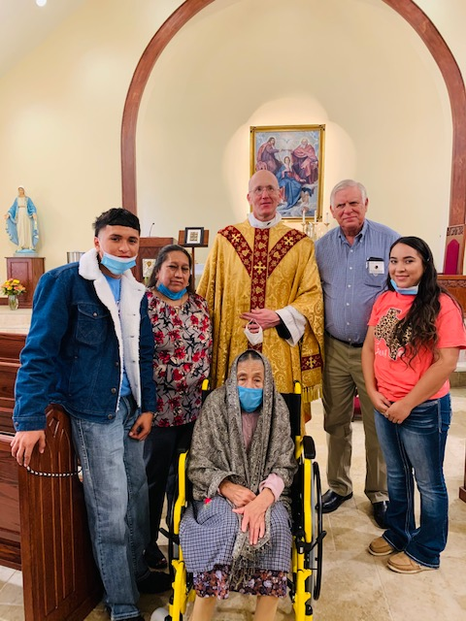
Fr. Fenton and SK John Schmitz are joined by MS Cabrera and members of her family as they happily accept the wheelchair provided by the knights of Council 12523.
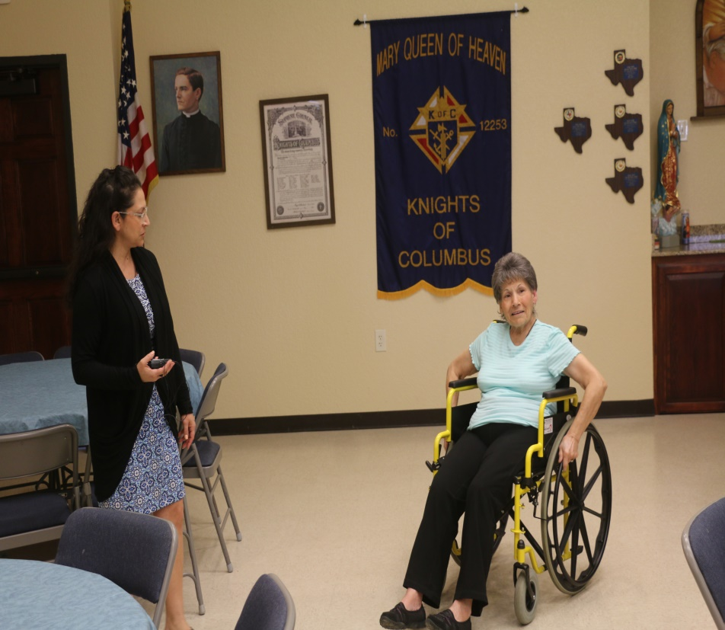
MS Pat Kamp explained to the Fox Network reporter how the wheelchair changed her life. She related that she had regained some independence with the mobility provided by the chair. Carol Kamp, her daughter, looked on with pride, as her mother smiled and said she was now able to gather around the dining table and again enjoy family meals.

