Assembly 2570 Fourth Degree
Newsletter September 2020
The September monthly meeting was held via zoom due to the on-going COVID restrictions on the 27th.
The biggest news at this meeting was the announcement that we have two new sir knights in our assembly. Carlo Caravetta from council 11978 and Robert Fletcher from council 10524 completed their exemplifications on September 19th at Farmers Branch. Congratulations and welcome to the team.
The next exemplification is scheduled for October and the assembly has two more candidates. Tom Calderon from council 10524 and John Schmitz are planning to attend that exemplification. If you missed the meeting where the exemplification details were discussed and you would like to attend please contact the faithful navigator for details of the event.
The assembly presented a ciborium to the St. Therese parish in Canton in the memory of deceased Sir Knight Adan Perez.
FN reported the shirt order is in progress, but not many brothers have signed up on order sheet. FN will send the order form out again.
The next big event scheduled is the Chain of Life at the Athens Square scheduled for October 4th from 2-4 PM. This is an important event to publicly pray the rosary to end abortions. SK Juan Martinez will be our team captain for this event.
Our sir knights are very active in pro-life activities and were highlighted for their activities in several articles featured by the Texas Knight publication at the tkof.org site.
Pictured below are the crosses set up by Sir Knight Juan Martinez to raise public awareness to the cost in lives taken through abortion each day.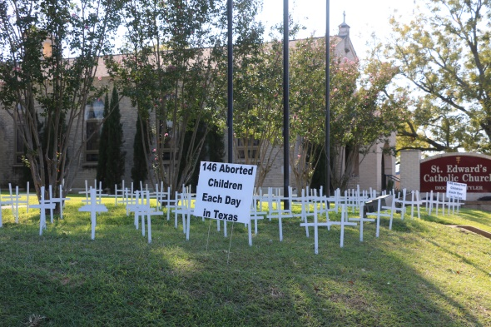
Pictured below is Fr. Lowry leading the rosary during the Chain of Life event at the Athens Town Square. SK Juan Martinez assisted with planning this event and coordinated the logistical support.
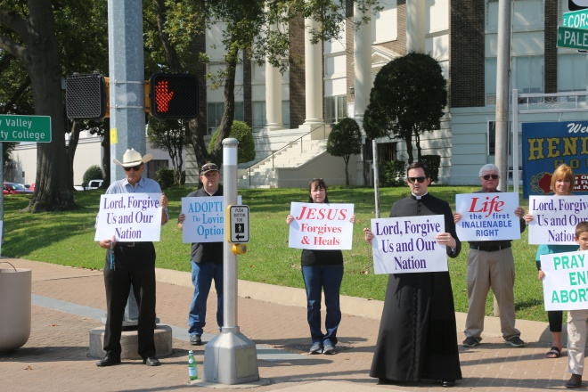
Pictured below is Fr. Fenton during silver Rose services at Mary Queen of Heaven, Sir Knights Larry Pfeifer, John Schmitz, and John Sumpter were the leaders to arrange this event for the MQH parish.
