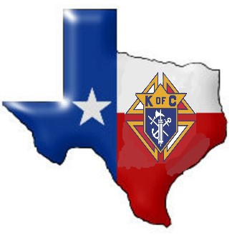
… from the Texas State Council

www.tkofc.org
Volume 2022 Issue 12 30-60-90 Day Outlook December 2022

Christ Be Our Light  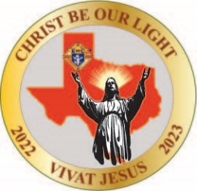  Terry Fruge (Beth)  State Deputy  713-417-0571  tbfruge@comcast.net  Most Reverend Bishop  Michael Sis  State Chaplain  San Angelo, TX  325-651-7500  Rev. Mel Bessellieu  Asst. State Chaplain  Ron Alonzo (Margo)  State Secretary  361-947-1346  skronalonzo1202@gmail.com  Robert “Bob” Goss  State Treasurer  334-538-1415  bob@gosslaw.com  David Pels (Susan)  State Advocate  817-807-2982  b_mallory@att.net  Bruce Mallory (Cathy)  State Warden  817-807-2982  b_mallory@att.net  Alfredo Vela, IPSD (Rosa)  Supreme Director  956-500-0169  alfredovela@hotmail.com |  | From the Texas State Council:  KEEP IT GOING!  Terry Fruge, Texas State Deputy  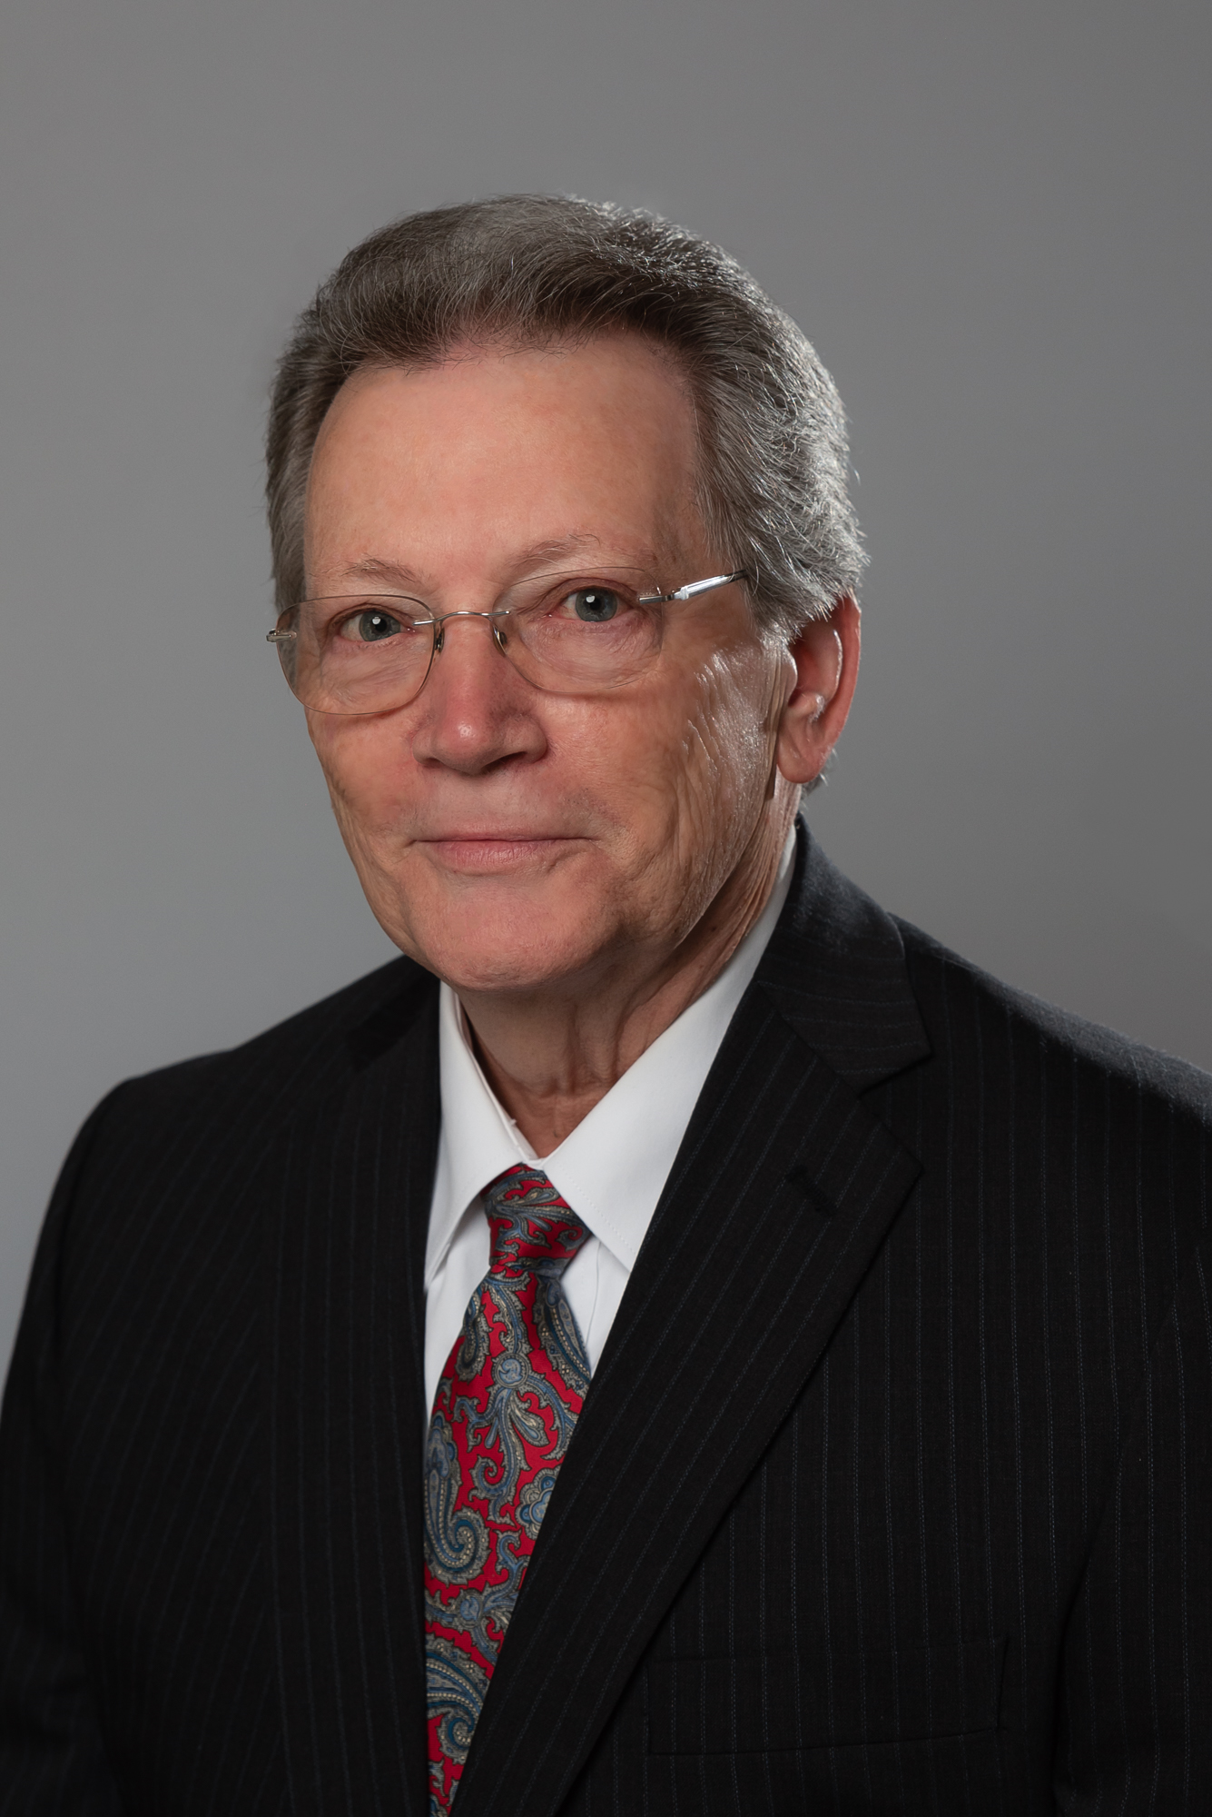  Terry Fruge  State Deputy  From the Desk of the State Secretary  The Importance of Per Capita  The Texas State Council a Non-Profit Organization is supported by its Councils. Councils’ Per Capita are monies paid to support the everyday activities of the Texas State Council. The State Per Capita $8.00 assessment per member has remained the same for over 28 years. Texas is one of the few jurisdictions that has a State Office with employees to keep track of forms and the finances of the State. This fee should be included in the dues, along with the Supreme fees.  The Texas State Council is to support the interest of its members. In Texas, councils have the option not to pay state per capita, and yet those councils still receive some form of benefits and representation, typically other non-profit organizations would require per-capita or dues payment to receive any benefits. In exercising the option, delinquent councils or their representatives are ineligible to participate in state sponsored activities and/or events such as seating delegates at the state convention, state athletic events such as softball, bowling and golf, state youth free-throw and educational scholarships, etc. State per Capita obligations should also be paid each year to ensure the efficient running of the Texas State Council and its programs, and to provide each member the opportunity to participate in those programs. Finally, each Council owes it to its members to provide meaningful and enriching Social and Spiritual Programs to encourage growth of the Order, increased Member participation, and prolonged Retention.  How Per Capita is assessed:  State Per Capita is an assessment and payment, required per Article V, Sections 1 and 2 of the  Texas State Council Bylaws. State Per Capita based on the Council roster as of July 1, with  adjustments for Honorary life, inactive insurance, and disabled. Once again, the State Per Capita is used to fund the operation of the Texas State Council. At least one-half of the assessment is due upon receipt of this notice sent earlier this fraternal year, on July 31, 2022. The remaining amount shall be paid on or before March 1, 2023. Councils who pay their State Per Capita in full by December 31, 2022, will meet one of the requirements for the Quick Start Award and the Lone Star Award for Excellence with Distinction award. Councils who pay their State Per Capita in full by March 1, 2023, will meet the requirement for the Lone Star Award for Excellence. If you haven’t paid your council’s Per Capita yet, please do so as soon as possible. Remember, you can pay your State Per Capita online through a link on the State’s web page www.tkofc.org
Christ Be Our Light  Executive Secretary  Mike McLaughlin (Dawnn)  512-442-1492  mikem@tkofc.org  State Admin Accountant  Kari Jordan  512-442-1492  kjordan@tkofc.org  State Admin  Council Records  Kathleen McLoughlin  512-442-1492  kathleenm@tkofc.org  Texas State Council  6633 Hwy 290 East  Suite 204  Austin, TX 78723-1157  512-442-1492 - office  512-326-1492 - fax |  | Membership:  MEMBERSHIP:  There was the true Light which, coming into the world, enlightens every man. (Jon 1:9)  The Season of Advent is a time to reflect on the coming of Jesus as the light in darkness.  The faithful will light one candle each week of Advent, on Sunday, until all four candles are lit. As Christmas draws nearer, each candle brings a little more light into the darkness.  Throughout the first week of Advent, how will you share and remember the Old Testament prophets who foretold of Jesus’ coming with hope and anticipation?  How can you reflect on your life and work on becoming better-versions-of-yourself in preparation for Jesus’ coming throughout the second week of Advent? Will you remember the journey Joseph and Mary took from Nazareth to Bethlehem?  In the third week, as we become filled with joy for the near arrival of Jesus on Christmas day, how will you reflect on the joy the shepherd's felt at the birth of Jesus? How will you share this joy with others?  How will you rejoice in the endless love that God has for us, which is made apparent in the birth of his Son? Will you share the good news of God's love brought to us from the angel Gabriel, during the final week of Advent?  This Advent, how are we sharing the Light Christ placed in each of us? Are we sharing our Light with men who need what membership in the Knights of Columbus has to offer?  We have the balance of this month to accomplish our goal of 2238 new members before December 31, 2022. We need approximately 460 new members to achieve this mark. We will not fail!  Online Membership  The Online Membership Application has been revised to one-page. Please become familiar with the new look and feel. This is the best way to bring a man into the Order.  Continue to offer Free Online Membership to every practical Catholic gentleman. The Supreme Promo Code, BlessedMcGivney, affords one year of free Online Membership.  All Council/District Active  Every Council Active initiative is designed to encourage all councils to recruit at least one new member during the fraternal year.  We are 5 months into this fraternal year, and we have just over 400 Councils from across the state which have not yet recruited a new member. Texas needs your support. We are counting on your assistance to grow the order.  VIVAT JESUS!  Derek W. Rabey, Membership Director  Calendar items:  30 Days:  Offer one-year of Free Online Membership to every practical Catholic Gentleman you encounter  Schedule follow-up session(s) to contact all potential new Council members  Schedule and conduct your Council (or District) Exemplification of Charity, Unity, and Fraternity  60 Days:  Offer one-year of Free Online Membership to every practical Catholic Gentleman you encounter  Schedule follow-up session(s) to contact all potential new Council members  Schedule and conduct your Council (or District) Exemplification of Charity, Unity, and Fraternity  90 Days:  Offer one-year of Free Online Membership to every practical Catholic Gentleman you encounter  Schedule follow-up session(s) to contact all potential new Council members  Schedule and conduct your Council (or District) Exemplification of Charity, Unity, and Fraternity  Education, Training, & Communications:  Our team is here to fulfill all your needs to be a Star Council. Visit www.kofc.org or www.tkofc.org at least weekly. Check out the Star Guide Section on the State website & download the latest version. Email all forms to the correct Supreme email address (located in the Star Guide) & to the Texas State Council at forms@tkofc.org. Copy all forms to your District & Diocesan Deputy.  December – 2nd Quarter done.  December 2-4 – Midyear Meeting – Round Rock, TX – All Diocesan & District Deputies; watch for registration email  December 8 – Solemnity of the Immaculate Conception  December 10 – International Crossing of the Silver Rose – Laredo, TX  December 12 – Feast Day of Our Lady of Guadalupe  December 15 – 1st Billing for New Fraternal Year should already be sent. The Retention Process has begun. Good time to start gathering information for the Annual Fraternal Survey form #1728  December 15—Form 10784 Family of the Month (for November) due  December 25 – Christmas  December 31 – Quick Start Award deadline (Honor Roll State Charities & State Per capita)  District Deputy Semi Annual Audit Form #944a Due  January 2022 – 3rd Quarter begins.  Midyear Diocesan Conferences  January 1 – Solemnity of Mary, Mother of God  January 15 – 2nd billing to be sent  January 28 – March for Life – Austin, TX  January 31 – Annual Survey of Fraternal Activities – Form 1728 Due  January 31 – Partnership Profile with Special Olympics Report – Form 10784 Due  January 31 – Charles ‘Chic’ O’Conner Annual Memorial Award - applications due  Begin planning your March Membership Drives – order materials  February – 3rd Quarter 1/3 done.  February 15 – Semi-Annual Audit Due – Form 1295  February 15 - Form 10784 Family of the Month (for January) due  Diocesan Freethrows  Get your State Award applications ready & sent in by March 1. (See Star Guide)  Our Financial Secretary Trainers are ready to begin training new and established council officers, but especially Grand Knights and Financial Secretaries. Diocesan Deputies, please schedule your live training sessions by the end of August. David Solis (Chairman) dsolis4027@aol.com 915-238-8735 can assist you with scheduling training sessions. The room needs to have adequate wireless internet to accommodate all trainees. David can also schedule an online training session.  Vivat Jesus!  Ed Tydings, Education, Training, & Communications (ETC) Director
 | Christ Be Our Light  Membership Director  Derek Rabey (Veronica)  210-288-7353  skdr2001@gmail.com  Program Director  Carlos Martinez (Rosamar)  346-901-6966  carlosmartinez1223@gmail.com  Star Council Director  Bill Tillotson (Christina)  817-690-0556  william_tillotson@yahoo.com  Council Growth Director  David Zeigler (Laura)  903-926-0776  zigsr@att.net  Education, Training, & Communications Director  Ed Tydings (Carmen)  512-565-9749  edwardtydings@gmail.com  Charity Director  Reed Fontenot, III (Donna)  501-920-0102  reed.fontenot@att.net  Insurance Liason  Tony Rangel (Cindy)  281-931-9100  thomas.rangel@kofc.org  Texas Knight Editor/  TKOFC Webmaster  Mark Johnson  512-851-8000  mjohnson@creatdev.com |  | Programs:  Pro-Life & Pregnancy Resource Support  Please wear your ACE Wings proudly and promote all eligible to attain their Wings. Contact Tom Clark - Chairman for details  The Pregnancy Resources need continues. Please work with your programs team to promote this program and help the Order reach its goal to donate $5 million to pregnancy centers and maternity homes before the end of the 2022-2023 fraternal year! Digital ASAP resources are now available at kofc.org/asap.  Contact Andrew Clark – Chairman Ultrasound initiative for more details  Pilgrim Icon and Vocations Support  The Pilgrim Icon is available is now rotating across the State, please coordinate with our Chairman Tom Krueger. Our Seminarians continue with their curriculums and commitments to the Priesthood and depend on your Councils to offset their personal financial needs. Please take an active position in support of the RSVP program. Consider allocating some of your council’s budget for at least a $500 donation to earn a $100 refund from the Supreme Council. Visit kofc.org/rsvp to learn more.  Silver Rose  Contact your Worthy Grand Knight, Financial Secretary, or Program Director to order a good quantity of the Silver Rose Prayer Service Booklets (#4841) and Our Lady of Guadalupe Pledge Cards (#9754) through Supplies Online via Officers Online.  International Bridge Silver Rose Dec. 10, 2022 Laredo, TX.  30 Day Events  - Conduct the Catholic Citizenship Essay.  - Plan now to charter a Bus or travel to the State Pro-Life March Jan 28, 2023  - Soccer Score sheets for Supreme participation can be emailed to FraternalMission@kofc.org.  - Coats for Kids – Sizes limited Kids Lightweight not available, order Teen coats  - Continue to submit Catholic Citizenship Essay contest.  - Start the Shield a Badge Program  - Start (or continue) the Into The Breach Video Series.  - Helping Hands - who needs some assistance?  - Submit the Family of the Month  - Submit a Fraternal Program Report (#10784) for each activity you had this month  60 Day Events  - Attend the Texas State pro-Life March January 28, 2023 1:00 PM State Capitol Austin, TX  - Council Free Throw contests  - Keep Christ in Christmas Programs – there are several activities that fall under this  title: Journey to the Inn, Light up for Christ, Advent wreath blessing, and the poster  contest.  - Submit the Family of the Month  - Submit a Fraternal Program Report (#10784) for each activity you had this month  90 Day Events  - Conduct Diocese Free Throw Contest  - Submit Jan 15 Catholic Citizenship Essay contest.  - Submit the Family of the Month  - Submit a Fraternal Program Report (#10784) for each activity you had this month.  Please continue to promote your Councils and the Programs that sustain your success.  Let Christ Be Your Light!  Let Christ Be Your Light!  Carlos X. Martinez  State Programs Director  Star Council Awards  As we approach the midpoint of our Fraternal Year, it’s a great time to take stock of how we are doing against our goals we set for ourselves last summer. By doing this, every council, district and diocese can prepare ourselves to hit the ground running on January 1. We can set in place plans to assure our councils of earning the coveted Star Council award come June 30.  So where should each council be today? Well, for Star Council:  - The Report of Officers Chosen Form 185 and Service Program Personnel Report Form 365 should have been submitted to Supreme  - Councils should have held at least two events in each of the four Faith In Action Program areas of Faith, Family, Community and Life that you can use on your SP-7 Form later this spring (a total of four from each area are required)  - Councils should be membership recruitment active and hopefully at or above 50% of their goal  - The Grand Knight, Program Director, Family Director, and Community Director should be Safe Environment compliant  - Councils should have credit for at least one of the two required Fraternal Benefit events  - Councils should have paid their Supreme Per Capita assessment  For the Lone Star Awards:  - Councils should have paid State Per Caps (but no later than March 1)  - Councils also should have paid State Charities (but no later than March 1)  - Councils should have submitted their Council Audit Form 1295-1  If there are any of these intermediate points your council is short of, use December to get caught up. District Deputies should be helping their councils get there too. This is the right time to get caught up and be ready to drive to completion in the second half of the year.  There is a LOT of things coming up after the beginning of the year that every council should start planning for now.  DECEMBER  - Make sure State Charities and State Per Caps are paid in full to earn the Quick Start award.  JANUARY  - Hold Diocesan, District, and Council Midyear meetings to level set the rest of the year. Councils especially should plan events to assure having all the programs required for the Columbian Award Form SP-7 (Star Council Award) come June (or earlier).  - Submit Program Report Form 10784 for Special Olympics (Lone Star Award) and Survey of Fraternal Activities Form 1728 (Star Council Award) no later than January 31.  FEBRUARY  - Submit Council Audit Form 1295-2 by February 15.  MARCH  - Submit State Service Program Award nominations for your best programs. Also submit Family of the Year and Chaplain of the Year nominations. Also encourage kids in your parish to apply for State Educational Grants. All these are due March 1. (Only one needed for Lone Star Award).  ALL SPRING  - Continue to recruit new members to hit or exceed you goal  - Host Fraternal Benefit events for your council and parish  - Plan and execute your Faith In Action programs.  As Ben Franklin famously said: ““If You Fail to Plan, You Are Planning to Fail”. Grand Knights, District Deputies and Diocesan Deputies should be planning in December how to succeed in the coming second half or the Fraternal Year.  Bill Tillotson – State Council Awards Director  Council Growth  My Brother Knights,  Congratulations Austin Diocese – New Council # 18087 – Our Lady of Wisdom – Texas State University, San Marcos, TX Great job by the Diocesan Deputy Bill Tartaglia& DD 159 Victor Medina & our new Brother Knights at Texas State! WHO is next?  Congratulations Brownsville Diocese – Reactivation of Council # 13287 – San Juan Diego in McAllen, TX Great job by the Brother Armando Gonzalez, Diocesan Deputy Fernando Garcia & DD 207 Juan Lopez for this reactivation.  Councils still need to go online for your Supreme Per Capita Statement:  www.kofc.org> sign in>Click on Reports tab>Click on Financial Statement.  Contact us if you need help finding your statement. Please mail payment to:  Knights of Columbus Council Accounts, PO Box 382172, Pittsburg, PA 15251-8172. Do not mail the payment to Supreme. If you have already paid, thank you.  As of November 30, 2022 we had 119 Roundtables. Our Goal is 200. See totals below. Diocesan Deputies please keep your promise to meet your Roundtable goal. Please fill in this form. Note the Grand Knight MUST sign the form!  https://www.kofc.org/un/en/forms/council/roundtable_coordinators2629_p.pdf  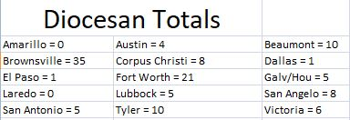  11 of our 15 Dioceses are in different stages of establishing a new Council or reactivating a Council. Keep up the work and follow the process. All the forms you need for either process can be found at the following link:  https://www.kofc.org/en/for-members/resources/council-development-forms.html  Please gather all forms, forward to the team or me. We want to send a complete package to Supreme at one time. This will also allow for the team to verify everything is in order.  Our team is ready to get you to your goal; all you need to do is ask.  Vivat Jesus! Let Christ Be Your Light!  David Zeigler, Council Growth Director  903-926-0776, zigsr@att.net  Texas State Council Charities:  Charity is the first and foremost principle of the Order. Our Bishops need us as 70% 0f your State Charity payments go back to the charity of choice for each Bishop! Let's review where we are after the first 4 1/2 months of the year:  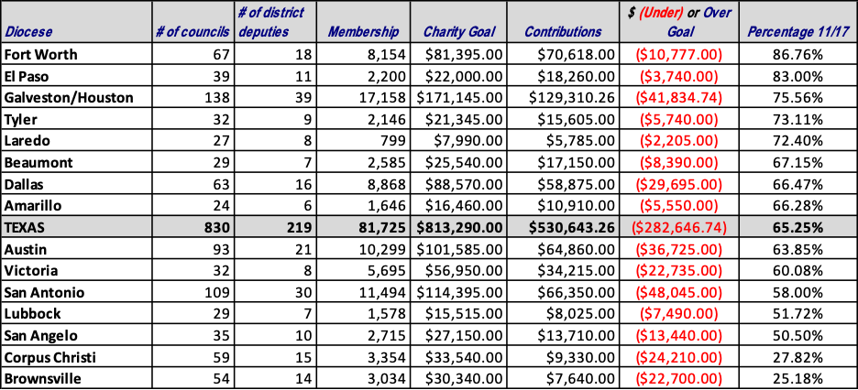  - In the first 17 days of November State Charity Contributions totaled $30,683.76 with an additional 21 councils meeting their goal.  - As of November 17, 2022, Fundraising Chairman David Keating reports State Council Charities contributions to State Council Charities have totaled $530,643.26 (65.2% of Goal).  - 385 Councils have met or exceeded 100% of their State Charity Goal compared to 305 Councils that had reached the same mark at this time last year. INCREDIBLE PACE!  - 41 District Deputies have met or exceeded their goal. Another 28 additional District Deputies are above 80%!  - Remember, let's focus on meeting our Charity Obligation before the end of December! Couple this with satisfying your State Per Capita obligations and your council will earn the Prestigious Quick Start Award!  - Of the 385 councils whom have net their State Charity Goal, 364 councils have also paid State per Capita and have earned Quick Start!  Reed Fontenot  State Charities Director  501-920-0102  Reed.fontenot@att.net
 | Finish Line Editor  Ed Tydings  512-565-9749  edwardtydings@gmail.com |  | Copyright © 2022, Knights of Columbus, Texas State Council, Austin, Texas  The “Finish Line” is published Monthly by the Texas State Council and electronically posted on the www.tkofc.org website by the Editor. The publication is a running outlook of the activities, events, award criteria, and form due dates for the next 30-60-90 days. Specific questions about Membership, Charities, Programs, Council Growth, Star Council, Education, Training, & Communications, and the specific subjects therein should be directed to the appropriate State Director.

