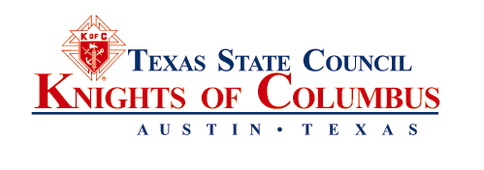
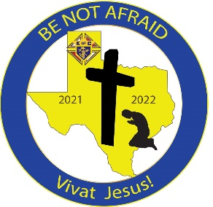
State Deputy
Alfredo Vela
alfredovela@hotmail.com

State Chaplain
TO: State Officers, Past State Deputies, District Deputies, Grand Knights
CC: Major Directors, Diocesan Deputies, Assistant Diocesan Deputies
FROM: Michael L. McLaughlin, Executive Secretary
RE: 2020-2021 Annual Report
DATE: March 17, 2022
The 2020 2021Annual Report of the Texas State Council is enclosed. It is being distributed in accordance with Article III, Section 13 of the Texas State Council Bylaws. It contains: (1) The written reports submitted to the 117th Annual State Convention by the State Deputy, State Secretary, State Treasurer and State Advocate; (2) The written reports submitted by the Major Directors; (3) Minutes of the 117th Annual Meeting of the Texas State Council (4) Minutes of the Annual Meeting of State Council Charities; (5) Audited Financial Statements prepared by Briggs & Veselka, Co.; (6) Texas State Council Bylaws; (7) State Council Charities Bylaws. It is posted under https://www.tkofc.org/downloads/state-publications
The 118th Annual Texas State Council Convention will be held April 29-May 1, 2022. The Hilton Americas Hotel located at 1600 Lamar, Houston, 77010 will serve as the host hotel. We hope your council will be represented. Be sure to submit your Delegates Certification Form and Banquet Reservation Form or register online by the deadline, April 4th. Banquet seating will be done on a first-come first-serve basis. Register for all host committee events by submitting forms and payments to the Corpus Christi Area Knights of Columbus Host Convention Committee according to the instructions on the forms or by registering online.
In accordance with Article III, Section 6, B of the Texas State Council Bylaws, State Advocate Bob Goss appoints Mikell West as alternate Parliamentarian. The rules contained in the 2020/12th edition of Robert’s Rules of Order Newly Revised shall govern the convention in all cases to which they are applicable and in which they are not inconsistent with the Texas State Council’s Bylaws and the Charter Constitution Laws of the Supreme Council of the Knights of Columbus and these standing rules.
Rule 1 of the Standing Rules of the State Convention state “The Nominating Committee for Supreme delegates shall consist of the eight chairmen from the eight caucus areas established by the State Officers”.
All state convention information and forms are found in the State Convention Forms booklet that was mailed to each of you. Every form in the booklet can be viewed and downloaded from the www.tkofc.org website. You can now register online. If you have any questions, call the State Office at (512) 442-1492.

Most Rev. Brendan Cahill
Bishop of Victoria
Associate State Chaplain
Rev. Mark Salas
pancratius@hotmail.com
State Secretary
Diego J. Peña
djpena57@me.com
State Treasurer
Terry Fruge’
tbfruge@comcast.net
State Advocate
Robert B. “Bob” Goss
bob@gosslaw.com
State Warden
Boyd Burris
Burrispb1549@att.net
Immediate Past State Deputy
T. Mark Evans
tmmpevans@gmail.com

Membership Director
Ron Alonzo
skronalonzo1202@gmail.com
Council Growth Director
Carlos Martinez
Carlosmartinez1223@gmail.com
Charity Director
Derek Rabey
skdr2001@gmail.com
Programs Director
Pat Henz
pghenz@yahoo.com
Education/Training Director
David Zeigler
zigsr@att.net
Star Council Awards Director
Reed Fontenot
reed.fontenot@att.net

State Office
Executive Secretary
Michael McLaughlin
6633 Hwy 290 East, Ste. 204
Austin, TX 78723
(512) 442-1492
(512) 326-1492 FAX
mikem@tkofc.org

